A Novel Dual-Hydrophone Localization Method in Underwater Sensor Networks

Sanfeng Zhu, Naigao Jin, Lei Wang, Xueshu Zheng, Shuailing Yang, Ming Zhu
School of Software
Dalian University of Technology
Dalian, China
sanfeng.zhu@gmail.com, ngjin@dlut.cn, lei.wang@ieee.org, xueshuzheng.steven@gmail.com, yangsl1008@gmail.com

Abstract—This paper proposes a novel dual-hydrophone acoustic source localization method for underwater sensor networks, called DHL. Despite the serious disturbance and noise, poor link quality and high bit error rates, long latency, limited bandwidth and low data rate in underwater acoustic source localization, we use the sign of TDOA (Time difference of arrival) as the binary measurement information (0/1) to convert the localization problem into plane cutting issues. We evaluate DHL with simulation which demonstrates that DHL achieves higher robustness than TDOA-based method in different aspects.
Keywords—Underwater Sensor Networks; Localization; Acoustic Source; Dual-hydrophone; Binary Information

Introduction
In underwater, radio signals attenuate rapidly, hence they can only travel to short distances while optical signals scatter and cannot travel far in adverse conditions, as well [1]. On the other hand, acoustic signals attenuate less, and they are able to travel further distances than radio signals and optical signals. Consequently, acoustic communication emerges as a convenient choice for underwater communications. However, it has several challenges, the bandwidth of the acoustic channel is low, and hence the data rates are lower than they are in terrestrial wireless sensor networks (WSNs). Data rates can be increased by using short range communications which means more sensor nodes will be required to attain a certain level of connectivity and coverage. In this case, the large-scale underwater acoustic sensor networks (UASNs) bares additional challenges for communication and networking protocols. Moreover, the acoustic channel has low link quality [2] which is mostly due to the multi-path propagation and time-variability of the medium. Furthermore, the speed of sound is slow (approximately 1500m/s) yielding large propagation delay. In addition to those, in mobile UASNs, the relative motion of the transmitter or the receiver may create the Doppler Effect. Besides, these communication channel related challenges, UASNs are also energy limited similar to other WSNs.
Although various localization algorithms have been proposed for terrestrial WSNs, UASNs’ unique properties have necessitated an innovative re-examination of problems related to localization [3]. Some localization schemes based on RSS (Radio signal strength) [4], TOA (Time of arrival) [5] or TDOA (Time difference of arrival) [6] could not be used in underwater environment [7, 8]. Indeed, propagation delays, motion induced Doppler shift, limited bandwidth, and multi-path interference render many previously proposed solutions inaccurate or infeasible [9]. Furthermore, 3D localization becomes even more challenging due to the economically-driven sparseness of USNs deployments [10]. A TDOA-based silent positioning algorithm is proposed for underwater sensor network [11]. An algebraic solution using TDOA and frequency differences of arrival (FDOAs) of a signal received at a number of receivers [12].
Due to above challenges, we explore to locate a signal acoustic source in underwater environment, and this paper offers the following intellectual contributions:
(1) Synchronization free. We adopt a lot of sensors which have dual time-synchronized hydrophones to resolve the time-synchronized requirement of conventional TDOA-based localization methods.
(2) Binary Information. We implement a simple GCC (Generalized Cross-Correlation) algorithm to weaken the demand of hardware to compute the precise value of TDOA to get the binary information.
(3) High robustness. Our method can reduce the multi-path effect in underwater acoustic source localization. Simulation evaluation results indicate our algorithm has strong robustness and high accuracy when errors (location error and angle error of hydrophones, or measurement errors) exist.
The rest of this paper is organized as follows: Section II presents the preliminary system overview. Section III details the system design. The simulation of the system is evaluated in Section VI. Finally, Section VII summarizes the conclusion and future works.

System Overview
Fig. 1 shows a layout of an underwater sensor network with an acoustic source S and many dual-hydrophone sensors, for the sake of clarity, the location and direction of hydrophones are known, and the distance between the dual-hydrophone is fixed. Each sensor node is attached to a surface buoy by a cable, which can transmit data between each other. When the sensed data is received by the buoy, it is transmitted to the central station by RF signal, then the server in the station will analyze the data. The goal of our work is to track the dominant sound source and to steer the beam to the direction of the active source.
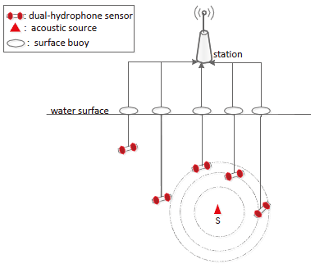
Fig. 1. System overview. A three-dimension UASN formed by randomly deployed sensors equipped with known location and direction hydrophones to locate the acoustic source. The sensors float with buoy.
Without assumptions of target movement models and without accurate range-based localization, for each sensor, if there exists an acoustic source, the source will emit a beep periodically. Once S emits a beep, it can broadcast its acoustic signal, and almost all hydrophones will receive the beep if all hydrophones work well when the sound is within their sensing range. After receiving the beep, each sensor will compute the value of TDOA from S to its dual-hydrophone through the simple GCC algorithm. In the presence of reverberations, for i-th sensor, if we draw a perpendicular plane to the line joining of its two hydrophones, it can divide the whole localization area into two regions, the sensor can use the sign of TDOA to judge the source whether at the left or right side of it marked with binary code 0 or 1. Then it will send the binary information 0 or 1 to the station. In the database of the station, we can use a matrix to store the corresponding binary information about the target to the sensors. After all the sensors which can sensing the signal send their cutting results to the server, it will analyze all the information of all sensors, and they can cut the plane into many small regions, and we can narrow the feasible region of target, then we will get a polyhedron containing the unknown source, the center of the polyhedron is the estimated location of the target.

Design
The top-level idea of DHL is to cut the whole localization area where dual-hydrophone sensors deployed into many small regions using the sign of TDOA. DHL can be divided into three phases. Phase I is the initialization step. Phase II starts when an acoustic event occurs. Phase III estimates the location of the acoustic source.

Phase I - Initialization
After all sensors are deployed, each sensor will report its direction and location of the pairwise hydrophone to the server through the buoy. With the location and direction information of all the sensor nodes and the size of the underwater area, the server can draw a map as the system overview.

Phase II – Binary Cutting
Once the acoustic source emits a beep, it will broadcast its acoustic signal quickly, and if the signal is in i-th sensor’s sensing range, it will use a simple GCC algorithm to compute the value of TDOA TDOA_{i} from the source to the two hydrophones, and stored the sign of TDOA_{i} in BinaryInfo_{i} to cut the localization space into two polyhedrons, which are bounded by the perpendicular plane of the pairwise hydrophone on one sensor, and Binary_data_{i} can be defined as
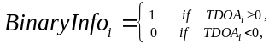 (1)
where 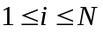, N is the total number of sensors, TDOA_{i} is the value of TDOA for the target to the i-th sensor.
To make it easy to understand, we just use 2D case to describe the process of DHL, we can extend it into 3D scenario when using perpendicular plane to cut the space, and all the formulas are the same. As shown in Fig. 2(a), supposing there is an acoustic source in the location area, the whole space can be divided into two regions by the perpendicular bisector Div(A) for the dual-hydrophone of A. According (1), if the value of TDOA from the dual-hydrophone to the source is bigger than zero, we mark the corresponding region with binary code 1, then the opposite region will be marked with 0. If we use all sensors ABCDE to cut the space, by judging the exact side of the target, and mark each cutting parts with binary code 0/1 and fill with different shadow lines, then the space will be cut into many small regions, we can narrow the area of the target. As it is shown in Fig. 2(b), the deep shadow one is the final region of the target.
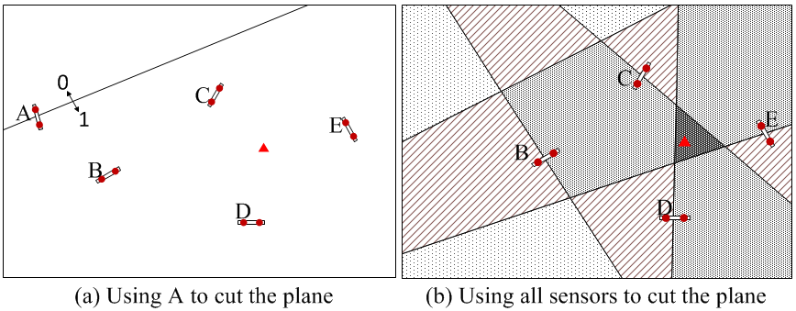
Fig. 2. Example of DHL using five sensors ABCDE to cut the plane.
In a real system, we cannot avoid reverberation and uncertain noises, so we cannot get very accurate acoustic signal. In order to reduce the impact of errors (location error, angle error and measurement error of dual-hydrophone) to the localization result. As the core idea of binary cutting is to cut the space and judge the feasible region according the sign of all TDOAs, so the final region of the target can be represented by , and if there exists some errors to judge the exact side of the target, the result R_{f} will be an empty set, so we cannot locate the target. In DHL, after using a sensor to cut the space, if the feasible region is empty set, we regard the sensor is invalid, and do not use it to cut the space in this iteration, enter another iteration.
To summarize, DHL is presented in Algorithm 1 shown in Fig. 3. The input is the location coordinates and directions of all hydrophones, and the binary information for all the sensors along with the space size R, the output is the estimated location of the acoustic source. Step 1 is the initialization phase, we assume the feasible region is R, Step 2 to 13 define a cutting function, whose function is to narrow the range of the target with the given condition.
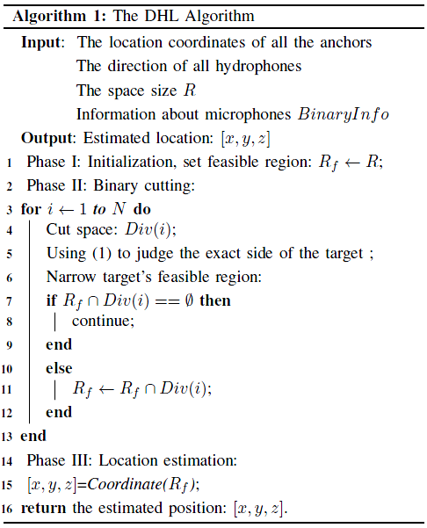
Fig. 3. Pseudo code of DHL algorithm.

Phase III – Location Estimation
After using all sensors to cut the space along with 0/1 binary information to narrow the region of the target, stored in R_{f}. We can locate the target by taking the center of the final region in calling Coordinate(R_{f}).

Simulation Results
In this section, we evaluate the performance of DHL with tradition hyperbolic intersection based TDOA method using MATLAB.

Simulation Settings
In our simulation experiments, 100 sensor nodes are randomly distributed in an 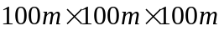area. And it is organized in an acquisitions that the position and angle of all anchors are assumed to be known in advance. The distance between the two hydrophones is 0.5m and remains fixed. To reduce the impact of the uncertainty of position and orientation to hydrophones on the accuracy of localization, we add a 10° angle error and 0.5m location error in all the simulations. All the statistics are running 1000 times for high confidence, and reported by CDF figure. We also simulate a traditional hyperbola-based TDOA method for comparison.

Performance in Static Networks
In this set of simulations, sensors in the network remain static.
Comparison with TDOA: We try to compare DHL with a traditional hyperbola-based TDOA method. TDOA-base method uses any group of four hydrophones to estimate the target's position. In the simulation, all parameters remain default, we sort the RMSE (root mean square error) results of TDOA-based method by ascend and choose the 20th percentile measurements in comparison with DHL shown in Fig. 4. As expected, DHL performs better than TDOA, which dues to the fact that TDOA can be very sensitive to the errors added to all anchors.
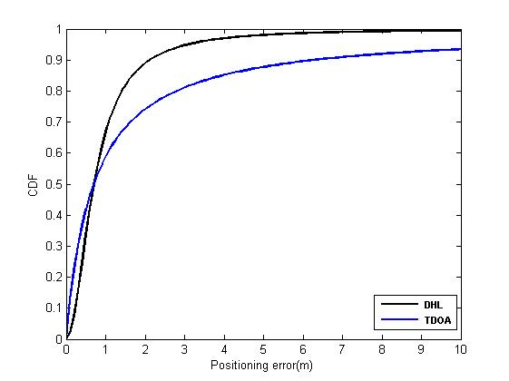
Fig. 4. Impact of sensor number.
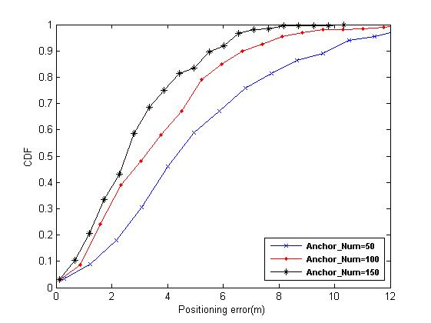
Fig. 5. Impact of sensor number.
Impact of sensor number: We investigate the localization error with different number of anchors from 0 to 200 with the step of 10, and other parameters remain default. Since the proposed method aims to narrow the range of the target by processing all anchors, we can assert that with more anchors, the whole area will be divided into more small parts, so more accurate localization estimation could be achieved by DHL. As shown in Fig. 5, we choose 50, 100, 150 anchors to express the CDF and positioning error for DHL. Fig. 5 demonstrates that the localization error rate decreases as the number of anchors increases for DHL, and we can always get the positioning result as the curve can reach 100%, because once there exists any error, if R_{f} equals to zero, we will regard the sensor is invalid, and do not use it to cut the space.
Impact of location error: In this experiment, we try to evaluate DHL using location error of anchors. In Fig. 6, we choose the location error with 0.5m, 1.0m and 1.5 m to test the positioning performance for DHL. Fig. 6 indicates that the location error of sensors has an effect on the positioning results. As demonstrated in Fig. 6, the positioning error varies little, which indicates DHL is robust.
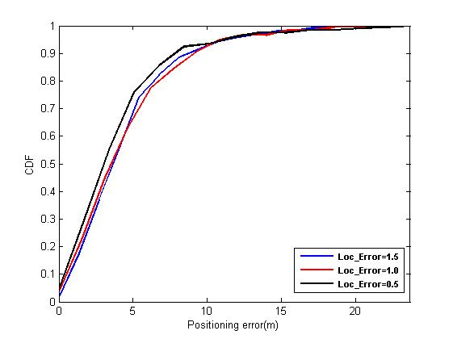
Fig. 6. Impact of location error.
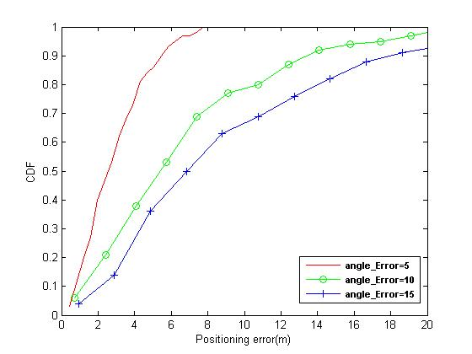
Fig. 7. Impact of angle error.
Impact of angle error: In the experiment, we perform the impact of the angle error of anchors for DHL. As the direction of anchors are uncertain, we assume the angle error may influence the localization accuracy. The Fig. 7 confirms it. As shown in Fig. 7, the positioning errors for DHL are rising as angle errors of anchors increase. So we have sufficient confidence to conclude that angle error of anchors will influence the localization accuracy.

Conclusion
This paper presents DHL, a novel underwater acoustic source localization method that uses dual-hydrophone sensors to locate the unknown acoustic source. By using dual-hydrophone, we can convert the localization problem into plane cutting issues by using probability and binary information to locate the target. Simulation evaluation results demonstrate that the DHL is much more accurate than TDOA besides, DHL achieves fault tolerance, good accuracy and great flexibility with low cost when errors exist. As ongoing and future work, we will conduct experiment in a swimming pool using our dual-hydrophone sensors, what's more, we also try to locate multiple targets.

Acknowledgment
This work is supported by Natural Science Foundation of China (Grants No. 61070181, 61272524 and 61202442) and the Fundamental Research Funds for the Central Universities (Grants No. DUT14ZD218 and DUT14QY29). This work is also supported by Specialized Research Fund for the Doctoral Program of Higher Education (Grant No. 20120041120049).

References
- J. Partan, J. Kurose, and B.N. Levine, “A survey of practical issues in underwater networks,” ACM SIGMOBILE Mobile Computing and Communications Review, vol. 11, no. 4, pp. 23-33, 2007.
- J. Heidemann, W. Ye, J. Wills, A. Syed, and Y. Li, “Reseach challenges and applications for underwater sensor networking,” in IEEE Wireless communications and Networking Conference, vol. 1, pp. 228-235, 2006.
- H.P. Tan, R. Diamant, W.K. Seah, and M. Waldmeyer, “A survey of techniques and challenges in underwater localization,” Ocean Engineering, vol. 38, no. 14, pp.1663-1676, 2011.
- Y.S. Yan, H. Y. Wang, X.H. Shen, F.Z. Yang, and Z. Chen, “Efficient convex optimization method for underwater passive source localization based on rss with wsn,” in IEEE International Conference on Signal Processing, Communication and Computing, pp. 171-174, 2012.
- S. Fischer, H. Grubeck, A. Kangas, H. Koorapaty, E. Larsson, and P. Lundqvist, “Time of arrival estimation of narrowband tdma signals for mobile positioning,” in IEEE International Symposium on Personal, Indoor and Mobile Radio Communications, pp. 451-455, 1998.
- J. Scheuing and B. Yang, “Disambiguation of tdoa estimation for multi-ple sources in reverberant environments,” IEEE Transations on Audio, Speech, and Language Processing, vol. 16, no. 8, pp. 1479-1489, 2008.
- I.F. Akyildiz, D. Pompili, and T. Melodia, “Underwater acoustic sensor networks: research challenges,” Ad hoc networks, vol. 3, no. 3, pp. 257-279, 2005.
- V. Chandrasekhar, W.K. Seah, Y.S. Choo, and H.V. Ee, “Localization in underwater sensor networks: survey and challenges,” in ACM international workshop on Underwater networks, pp. 33-40, 2006.
- F. Koushanfar, S. Slijepcevic, M. Potkonjak, and A. Sangiovanni-Vincentelli, “Location discovery in ad-hoc wireless sensor networks,” in Ad Hoc Wireless Networking, pp. 137-173, 2004.
- A.Y. Teymorian, W. Cheng, L. Ma, X. Cheng, X. Lu, and Z. Lu, “3d underwater sensor network localization,” IEEE Transactions on Mobile Computing, vol. 8, no. 12, pp. 1610-1621, 2009.
- X. Cheng, H. Shu, Q. Liang, and D.H. Du, “Silent positioning in underwater acoustic sensor networks,” IEEE Transactions on Vehicular Technology, vol. 57, no. 3, pp. 1756-1766, 2008.
- K. Ho and W. Xu, “An accurate algebraic solution for moving source location using tdoa and fdoa measurements,” IEEE Transactions on Signal Processing, vol. 52, no. 9, pp. 2453-2463, 2004.

